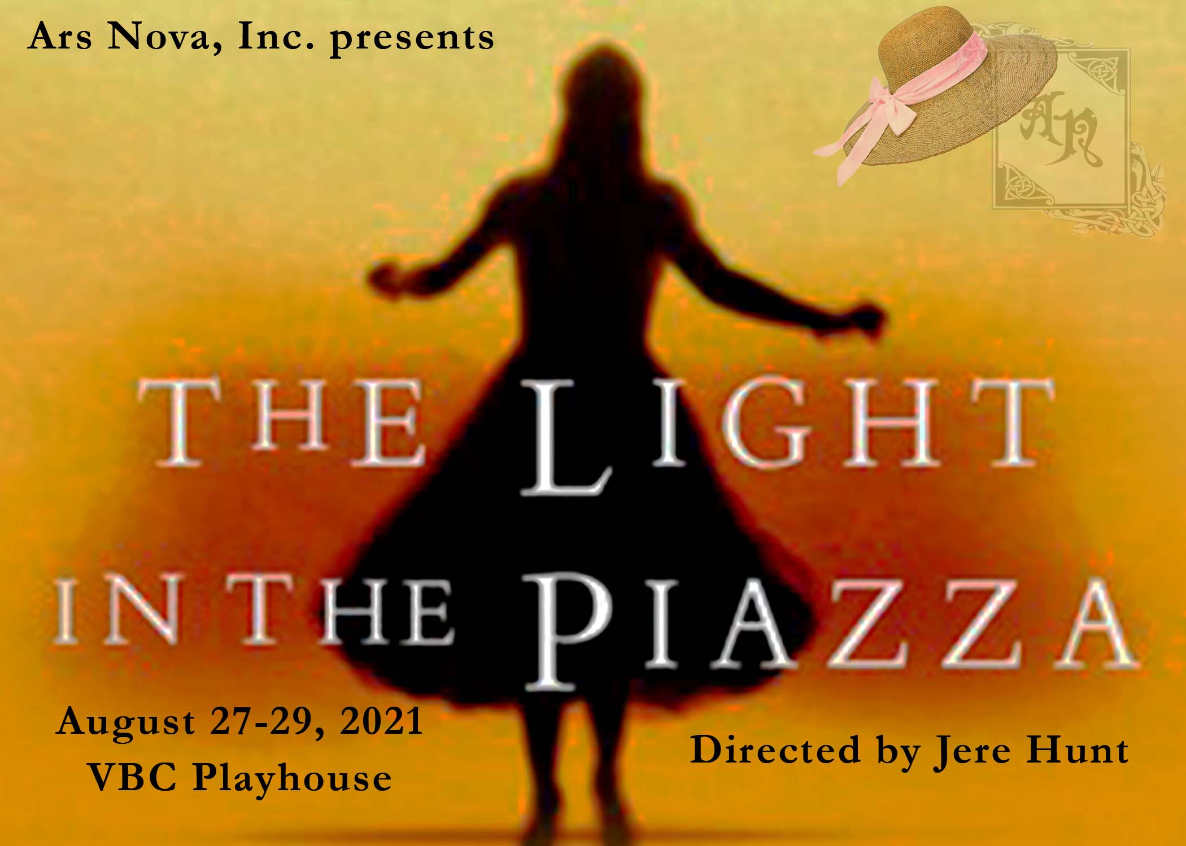
Friday, April 9 – 7pm
Saturday, April 10 – 2pm
*prepare 32 bars of a contemporary musical theatre or art song AND a 1-minute monologue*
Callbacks
Sunday, April 11 – 2 pm
*be prepared to read sides and learn selections from the score*

Rehearsals begin July 6
with principals starting some music rehearsals in June
Ars Nova School of the Arts
*Ensemble rehearses on Saturdays only until Aug 16*
Synopsis
The Light in the Piazza takes place in Italy in the summer of 1953. Margaret Johnson, the wife of an American businessman, is touring the Tuscan countryside with her daughter, Clara. While sightseeing, Clara--a beautiful, surprisingly childish young woman--loses her hat in a sudden gust. As if guided by an unseen hand, the hat lands at the feet of Fabrizio Naccarelli, a handsome Florentine, who returns it to Clara. This brief episode, charged with coincidence and fate, sparks an immediate and intense romance between Clara and Fabrizio. Margaret, extremely protective of her daughter, attempts to keep Clara and Fabrizio apart. As The Light in the Piazza unfolds, a secret is revealed: in addition to the cultural differences between the young lovers, Clara is not quite all that she appears. Unable to suppress the truth about her daughter, Margaret is forced to reconsider not only Clara's future, but her own hopes and dreams as well.

Roles (all principal roles require strong singing and acting)
Margaret Johnson, mezzo-soprano
an elegant, practical, and attractive American woman. Strong and self-assured.
Clara Johnson, soprano
Margaret’s daughter, young and naïve for her age with a youthful simplicity and exuberance
Fabrizio Naccarelli, tenor
a good-looking and charming Florentine with youthful and passionate energy
speaks and sings in Italian and very broken English
Giuseppe Naccarelli, baritone
Fabrizio’s slightly older brother, a “ladies’ man” - must have some movement ability
speaks Italian and English well, with a light accent
Franca Naccarelli, soprano
Guiseppe’s wife, very passionate and strong. Unhappy in her marriage, but loves her husband
speaks Italian and English, with a strong accent
Signor Naccarelli, bass/baritone
Fabrizio’s father, the epitome of a classic Italian gentleman. Charming and insightful
speaks Italian and English very well, with a light accent
Signora Naccarelli, soprano
Fabrizio’s mother, cunning and intelligent. The foundation of her family.
speaks in Italian, but sings in English (no accent)
Roy Johnson, non-singing role
Margaret’s husband, a successful American businessman
Ensemble, limited singing and a few spoken lines
primarily create street scenes and atmosphere

*Preferential consideration will be given to Ars Nova School of the Arts students in casting principal roles. All casting will be inclusive, and performers of all race/ethnicity, disability, age or gender/gender identity are encouraged to audition.*

